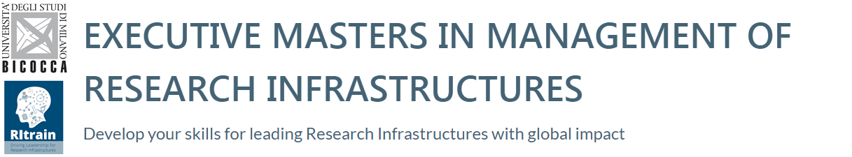

The Executive Masters in Management of Research Infrastructures is an international management development programme tailored to the specific needs of Research Infrastructures. This Programme is designed to give experienced science professionals the skills and knowledge they need to take on greater managerial responsibilities. Take the opportunity to improve your managerial skills.
More details: www.emmri.unimib.it/en

What can this Executive Masters offer you?
• A global network of Research Infrastructure colleagues in similar leadership positions
• An international Faculty composed by dedicated professors and acclaimed experts from research infrastructures
• A better understanding of how Research Infrastructures in different countries are responding to common challenges
• Greater awareness of your leadership strengths and weaknesses.
• Innovative ways to help your organisation become more effective.

The Masters programme gives you three alternative enrolment options:

A) FULL PROGRAMME
KEY FACTS  • Target: Executive  • Format: MBA Part-time  • Duration: 18 months  • Number of places available: 35  • Language: English  Deadline for application: July, 6th 2018  Admission results: July 2018  Programme start date: November, 13th 2018 | Who should Apply ?  • Director Generals, Chief Operating Officers or their equivalent  • Recently appointed or upcoming senior managers  • Heads of National Nodes  • Heads of Finance and Administration, HR and Communication  • Middle management  • Representatives of funding bodies and ministries responsible for RI funding

B) OPEN PROGRAMME
KEY FACTS  • Target: Executive & Middle Management  • Format: Tailored Training  • Language: English  Deadline for applications: More details on http://www.emmri.unimib.it/en/home-open-programme/ | This format gives you the opportunity to take individual modules to develop specific expertise if the full Executive Master is not required. We are expanding the portfolio of open-enrolment modules for 2018-2019. We can help you finding the course that meets your needs: CONTACT US

C) TEAM APPLICATION
KEY FACTS  • Target: Executive & Middle Management  • Format: Tailored Training  • Language: English  Deadline for application: July, 6th 2018  Admission results: July 2018  Programme start date: November, 13th 2018 | We offer Research Infrastructures the option to enter the programme as an organisation and split the 12 modules among staff members according to their organisational needs. This option is not covered by a Master certificate.  The Research Infrastructure will be awarded with a Certificate of Excellence in Research Infrastructure Leadership, flagging it as an organisation that values staff development, thereby enhancing its attractiveness as an employer.

